Car to Home Appliance: A Conceptual Proposed

Walmir Acioli e Silva; Robson G. da Cruz; Vinícius S. Souza; Vicente Ferreira de Lucena Jr.,*Senior* Member, IEEE  
Federal University of Amazonas, Manaus, Brazil  
was.acioli@gmail.com; robsoncruz.ufam@gmail.com; souzavinicius1993@gmail.com; vicente@ufam.edu.br

*Abstract*--This article presents a conceptual proposal of a system that collects and transmits data from the car to an environment capable of processing them and presenting to the user through common household devices (*e.g.,* tablets, digital TV) alerts that indicate anomalies of car operation or suggestions (*e.g.,* putting more fuel, filling tires) in order to avoid further problems. Car data is collected and stored through the On-Board Diagnostic Port (OBDII), then transmitted to an ambient intelligence to process them with artificial intelligence techniques. The resulting information is propagated in the home appliances through alerts when something abnormal is detected in the car. This work describes a conceptual architecture of the system and the data flow between the devices of the proposed system. In addition, two simple system application scenarios are presented.

# Introduction

The evolution of technology in data storage, devices connectivity, intuitive interfaces and others features are providing a better quality of life for their users [1]. Ambient Intelligence has been gaining focus lately because these ambients purpose to assist people with pervasive and ubiquitous computing devices [2]. These systems are discreet, interconnected, adaptable, dynamic, integrated and intelligent, implemented with low cost devices and easy handling gadgets. Thus, routine activities can be automated and improved by the Ambient Intelligence action, as an omnipresence of information technology in people daily lives.

For example, many home security systems may be considered an Ambient Intelligence application as it is getting more and more sophisticated through complex and collaborative devices. Those applications also take some actions in the controlled environment such as trigger alarms, lock doors automatically or notify users via internet pervasively and ubiquitously.

The well-known traditional cars are becoming gradually mobile computers, capable of process and generate several data collected in real time through On-Board Diagnostic II (OBDII) port (OBD scanner devices) [3], which are fundamental to correct and improve cars operations. The OBDII standard was developed to meet emission control specifications established by the California Air Resources Board (CARB) supported by the Environmental Protection Agency (EPA). The OBDII standardizes everything related to the diagnosis of devices following standards proposed by the Society of Automotive Engineers (SAE) and the International Standards Organization (ISO) [3]. The existing applications use the OBDII data to make problems diagnosis, show sensors status (*e.g.,* temperature) and real-time motor actuators status (*e.g.,* throttle position).

In addition, there are applications that use these data to develop driver assistant systems [4], alert the driver to change the motor oil [5], analyze the risks in roads using smartphones to process and send data to the Cloud [6], vehicle fleet management systems [7]. All of those works used different approaches and techniques artificial intelligence [8]. All the cited papers use an architecture where the smartphone collects and process data from cars, or send the data via 3G or Long-Term Evolution (LTE) networks to be processed in Cloud system to measure performance [9].

Wallace and colleagues proposed a device directly installed in the car where it collects data from OBDII port for a long period, generating a mass of data to be analyzed [10], creating an alternative for performance analysis.

The work proposed in this paper is similar to the above described systems from the aspect that uses the standard OBDII port data and artificial intelligence techniques to analyze them. In addition, a device installed inside the car will be developed, responsible for collecting, storing and transmitting data from the OBDII port to the house with ambient intelligence. Using the data collect from the car with the device in conjunction with the ambient intelligence computing resources and artificial intelligence techniques, the results of these processing will be shown by the home appliance (*e.g.,* tablets, digital TV) to the user in the form of an alerts (*e.g.,* waned car tire, low gasoline).

# Conceptual Proposal

This section describes the high-level system architecture in hierarchical layers. Fig.1 shows the layers, their composition and data flow.

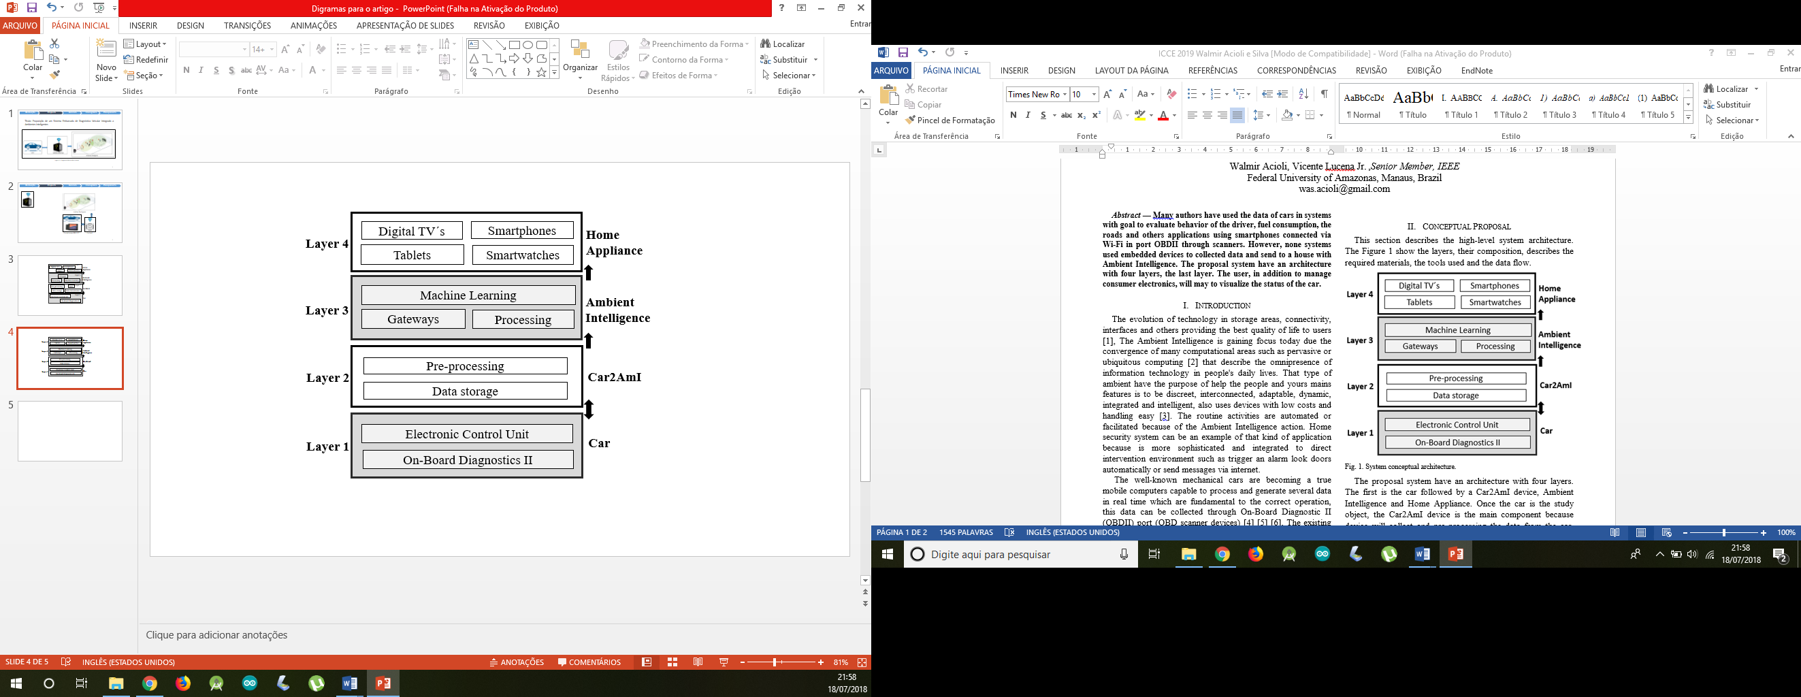

Fig. 1. System conceptual architecture.

The proposed system has an architecture divided in four layers. The first layer is the car, the study object. The second layer is Car2AmI device, the main connection component between layers 1 and 3. The third layer is the Ambient Intelligence that processes and distributes information in the home ambient, and the fourth layer is the Home Appliance that shows the data insights for users.

Figure 1 shows the architecture of the proposed solution. The solution is designed to emphasize that the Car2AmI device is one of the key elements of the system, responsible for the transmission of data between the car and the home, in addition, that data is also preprocessed. The processing is done in the house and the results are presented in the home appliances.

Layer 1 is responsible for assigning the car operating data that is controlled by the Electronic Control Unit (ECU) and can be accessed through the OBDII port. ECU is an embedded system that control all electronic parts of the car and the OBDII port allow collected data from ECU in real time via scanner or OBDIIadapter.

Layer 2 is responsible for mediating data transmission between the car and the Car2AmI device by sending messages requesting car data (*e.g.,* temperature, velocity, engine speed and others sensors). It also mediates the transmission of data stored on the device to the home. Car2AmI device is directly installed in the car to automatically connect with OBDIIadapter to collect and store when the car is turn on, after transmits data to the house with Ambient Intelligence whenever the device can establish connection.

Layer 3 is responsible for data processing and transmits the results to the home appliances. In addition, the main feature of this layer are the computational resources capable, besides receiving and processing data, detect possible problem or anomalies in data from car through data analysis with artificial intelligence techniques.

Layer 4 has the function of presenting information to users with alerts in cases that processing of the previous layer have detected changes in the car´s operating pattern. Those alerts will be sent through common devices in house that allow the human-machine interaction (*e.g.,* digital TV, smartphone).

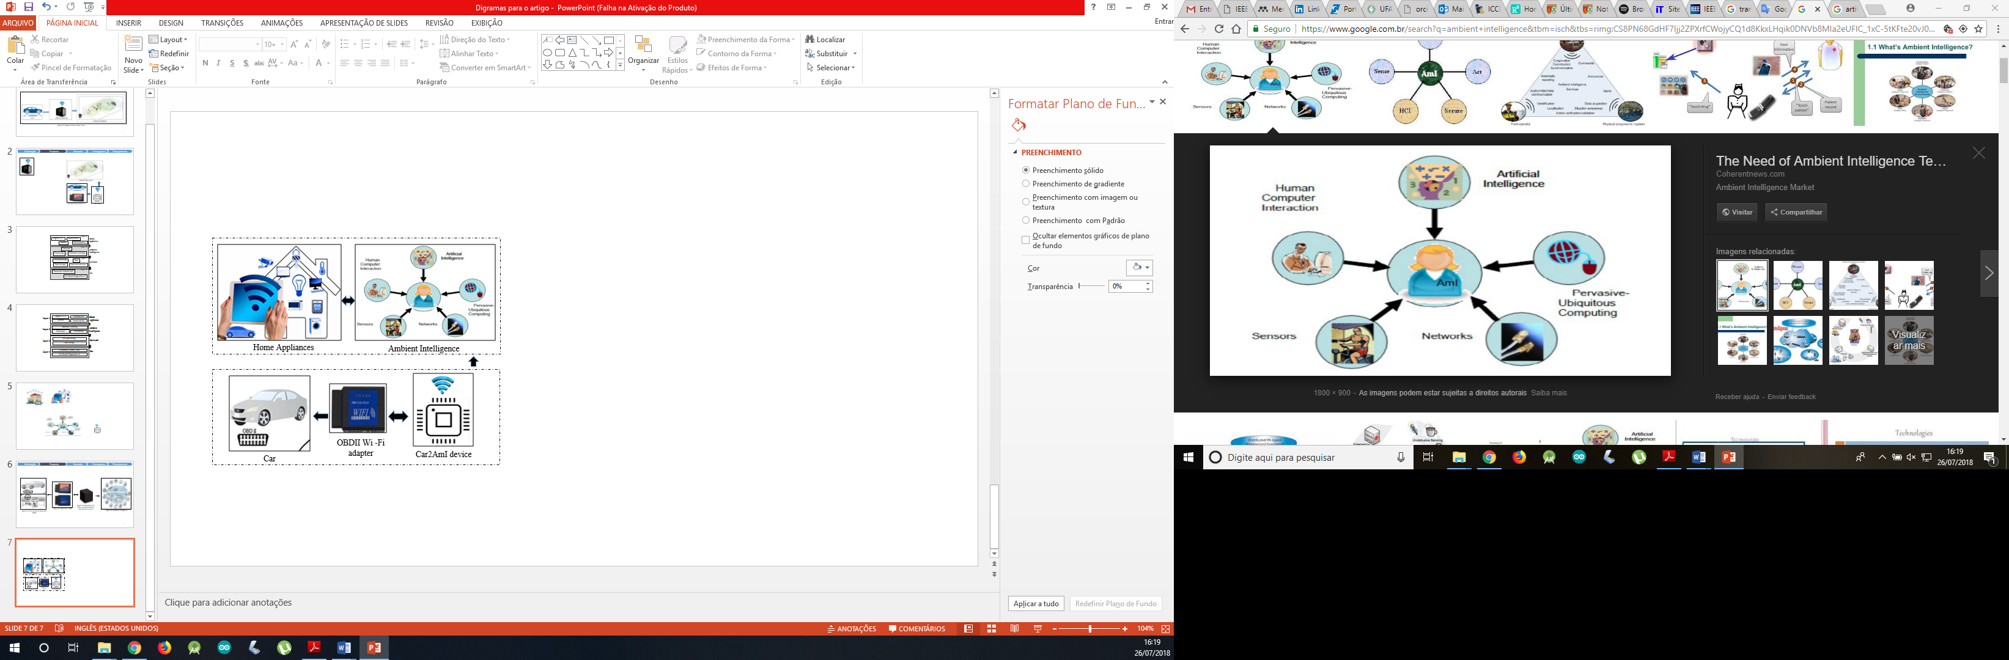

Fig. 2. Conceptual diagram of data flow of the system

The data flow of the system presented in Fig. 2 starts when the OBDII Wi-Fi adapter is connected to the car, then the Car2AmI device automatically connects to the adapter and starts collecting and storing data. Using opportunistic network techniques, the car will transmit the data when it is in range of the wireless home network. After, the data will be processed and presented on the home devices.

# Conclusion

Home appliances allow devices such as digital TV´s, smartphones and tablets work as access point, helping users to manage their consumer electronics in a house with Ambient Intelligence. In addition, the user will be able to receive alerts about anomaly detection or verify status of the car, thus, can prevent some problems by performing predictive maintenance.

Our future work will be the implementation of the Car2AmI device, to capture and preprocess data from the available OBDII. The application of the proposed system can be verified in 2 simple scenarios. Scenario 1 after a few days driving the user arrives in the house and when he turns on the digital TV, he receives an alert, informing him that the car tire needs calibration. Scenario 2 suggests with an alert on the tablet that the driver exits earlier and refuels the car because it has been detected that the route will be greater than the current autonomy.

References

1. B. de Ruyter and E. Aarts, “Ambient Intelligence: Visualizing the future,” ACM Proceedings of the working conference on Advanced visual interfaces (AVI 2004), 2004, pp. 203-208.
2. M. Weiser, The computer for the twenty-first century, Scientific American 265(3), 1991, pp. 94 -104.
3. Title 13, California Code Regulations, Section 1968.2, Malfunction and Diagnostic System Requirements for 2004 and Subsequent Model-Year Passenger Cars, Light-Duty Trucks, and Medium-Duty Vehicles and Engines (OBDII). 2013, pp. 1-136.
4. S. H. Chen, J. S. Pan, and K. Lu, “Driving Behavior Analysis Based on Vehicle OBD Information and AdaBoost Algorithms,” Proceedings of the International MultiConference of Engineers and Computer Scientists 2015 Vol I, IMECS 2015, pp. 102-106.
5. J. Siegel, R. Bhattacharyya, A. Deshpande and S. Sarma, "Vehicular engine oil service life characterization using On-Board Diagnostic (OBD) sensor data," IEEE SENSORS 2014 Proceedings, Valencia, 2014, pp. 1722-1725.
6. M. Amarasinghe, S. Kottegoda, A. L. Arachchi, S. Muramudalige, H. M. N. D. Bandara and A. Azeez, "Cloud-based driver monitoring and vehicle diagnostic with OBD2 telematics," 2015 Fifteenth International Conference on Advances in ICT for Emerging Regions (ICTer), Colombo, 2015, pp. 243-249.
7. R. Malekian, N. R. Moloisane, L. Nair, B. T. Maharaj and U. A. K. Chude-Okonkwo, "Design and Implementation of a Wireless OBD II Fleet Management System," in IEEE Sensors Journal, vol. 17, no. 4, pp. 1154-1164, Feb.15, 15 2017.
8. C. Augenstein, N. Spangenberg and B. Franczyk, "Applying machine learning to big data streams: An overview of challenges," 2017 IEEE 4th International Conference on Soft Computing & Machine Intelligence (ISCMI), Mauritius, 2017, pp. 25-29.
9. M. V. Martínez, I. D. Campo, J. Echanobe and K. Basterretxea, "Driving Behavior Signals and Machine Learning: A Personalized Driver Assistance System," 2015 IEEE 18th International Conference on Intelligent Transportation Systems, Las Palmas, 2015, pp. 2933-2940.
10. B. Wallace et al., "Automation of the Validation, Anonymization, and Augmentation of Big Data from a Multi-year Driving Study," 2015 IEEE International Congress on Big Data, New York, NY, 2015, pp. 608-614.